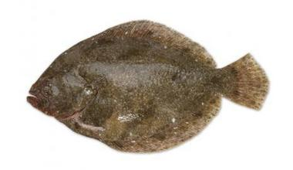
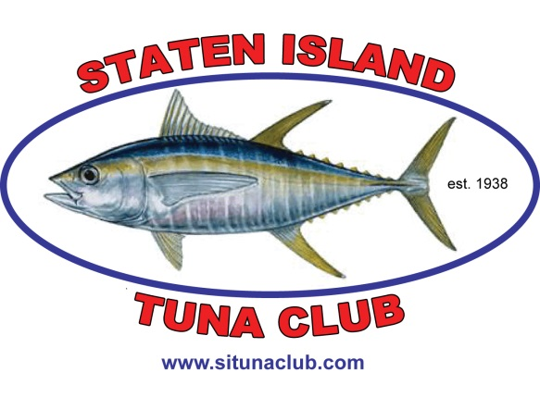
Proudly Presents

PINK RIBBON FLUKE TOURNAMENT
Open to beach / jetty / or boat
Help us to raise money by getting sponsors to sponsor YOU for this competition!

Last year we raised over $12,000
This year’s target is $15,000
Saturday – July 8, 2017
6:00 am – 5:00 pm
Only women may compete in the event!
Any checks must be made payable to American Cancer Society

Trophies for 1st , 2nd and 3rd Places
Honorary plaque for the angler that raises the most money!

Captain’s Meeting Friday, July 7, 2017 at 5:00 – 7:00 pm at Captains Marina
187 Mansion Ave., Staten Island, NY
Awards Ceremony to follow the Tournament

For Information Call:
Ramez Hawileh - (917) 418-7779 or Rob Crocitto – (917) 747-7541
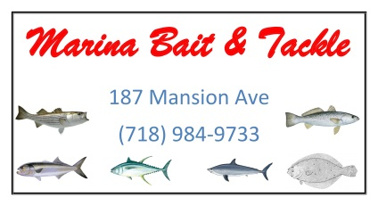

Name of Fisherwoman___________________________________________

Target Amount to Raise $_______________________________________

All donations must be brought to the Captains Meeting, any checks must be made payable to American Cancer Society

Name Email Address Donation Receipt

1.____________________________ _____________________________________ $_______________ yes / no

2.____________________________ _____________________________________ $_______________ yes / no

3.____________________________ _____________________________________ $_______________ yes / no

4.____________________________ _____________________________________ $_______________ yes / no

5.____________________________ _____________________________________ $_______________ yes / no

6.____________________________ _____________________________________ $_______________ yes / no

7.____________________________ _____________________________________ $_______________ yes / no

8.____________________________ _____________________________________ $_______________ yes / no

9.____________________________ _____________________________________ $_______________ yes / no

10.___________________________ _____________________________________ $_______________ yes / no

11.___________________________ _____________________________________ $_______________ yes / no

12.___________________________ _____________________________________ $_______________ yes / no

13.___________________________ _____________________________________ $_______________ yes / no

14.___________________________ _____________________________________ $_______________ yes / no

15.___________________________ _____________________________________ $_______________ yes / no

16.___________________________ _____________________________________ $_______________ yes / no

17.___________________________ _____________________________________ $_______________ yes / no

18.___________________________ _____________________________________ $_______________ yes / no

